Student Records System – Entity Design

Section 1: Entity list
• Student
• Course
• Enrollment
• Grade
• Department
• Faculty

Section 2: Attributes and keys

• Student:
Attribute Name | datatype | Example
StudentID(PK) | integer | 4JN23AI040
FirstName | String | John
LastName | String | Wick
DepartmentID(FK) | integer | 40
DOB | Date | 27-04-2005

• Course:
Attribute Name | datatype | Example
CourseID(PK) | integer | AI601
CourseName | String | DBMS
Credits | integer | 4
DepartmentID(FK) | integer | 40

• Enrollment(Junction):
Attribute Name | datatype | Example
EnrollmentID(PK) | integer | 640
StudentID(FK) | integer | 4JN23AI040
CourseID(FK) | integer | AI601
EnrollDate | Date | 2-3-2026

• Grade:
Attribute Name | datatype | Example
GradeInPoint | Decimal | 8.0
EnrollmentID(FK) | integer | 640
GradeValue | char | A

• Department:
Attribute Name | datatype | Example
DepartmentID(PK) | integer | 1
DepartmentName | string | AIML

• Faculty:
Attribute Name | datatype | Example
FacultyID(PK) | integer | 101
DepartmentID(PK) | integer | JNN001
Name | string | Josh

Section 3: Relationship Descriptions
- Department to Student: One Department can have many Students, but each Student belongs to only one Department.
Cardinality: One-to-Many (1:M).
- Department to Faculty: One Department employs many Faculty members, and each Faculty member is assigned to one Department.
Cardinality: One-to-Many (1:M).
- Department to Course: One Department can offer many Courses, but each Course is owned to a single Department.
Cardinality: One-to-Many (1:M).
- Student to Course: Many Students can enroll in many different Courses, and each Course can have many Students enrolled in it.
Cardinality: Many-to-Many (M:M).
- Enrollment to Grade: Each Enrollment record is associated with exactly one Grade record of the student's performance in that sem of the course.
Cardinality: One-to-One (1:1).

Section 4:ERD Diagram
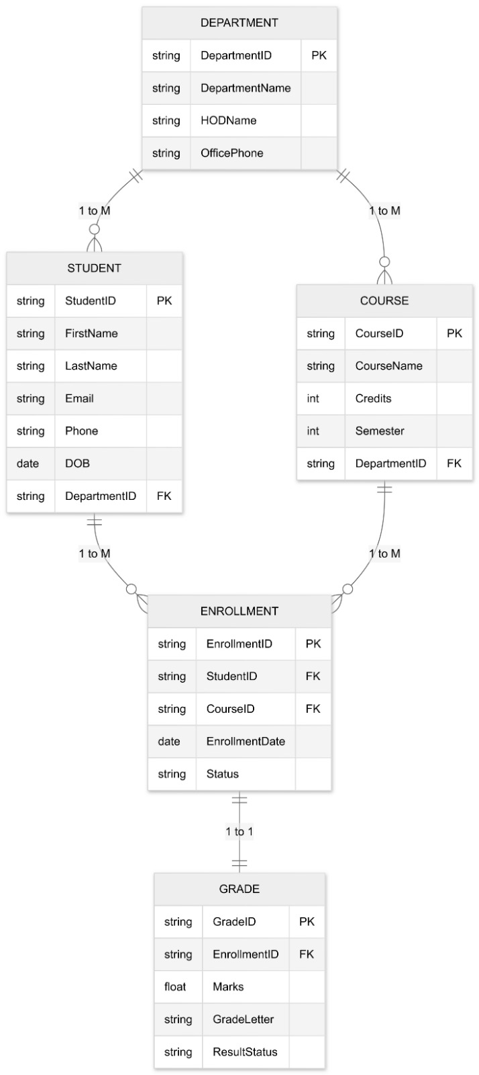

Section 5: Justification
1. Enrollment is its own entity because it acts as the Junction Table needed to break the complex "Many-to-Many" link between Students and Courses into two manageable "One-to-Many" links.
2. Grade is linked to Enrollment because a grade is the result of a specific student taking a specific course; linking it directly to the student would cause data inconsistency.

